

Clubroom Hire Information
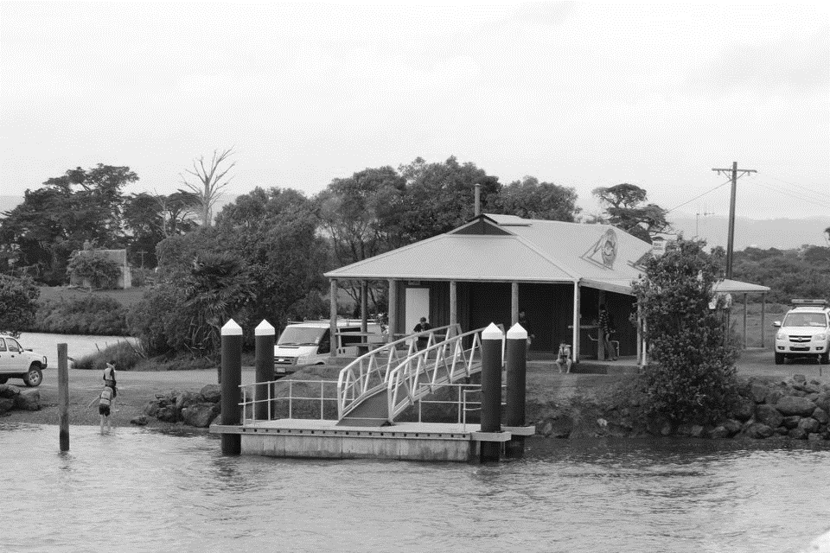
  - Information about the venue

Waipu Boat and Fishing Club Inc was incorporated in 1963. The Clubhouse is situated at 100 Nova Scotia Drive, Waipu, on the southern side of McLean Bridge.

The area of the Clubhouse is 44 square metres, with a further undercover veranda area with seating of 30 square metres. There is also a grassed area on the upper level. The clubhouse is situated on 1,400 square metres of land and there is generous parking area. Note the pontoon is a public area.

The Club does not have a licence for selling liquor, and it is acceptable to serve liquor on the premises. Hirers are required to operate any alcohol use within the constraints of the law. If alcohol is to be sold, then a Special Licence must have been obtained from the Liquor Licencing Authority and be displayed in accordance with the Sale of Liquor Act 2012.

The inside of the Clubhouse is a non-smoking area. Smoking is allowed in the undercover veranda area. In the event veranda curtains are used due to bad weather, the area becomes non-smoking.

- Small kitchen with electric oven and induction stove top, microwave, pie warmer, single door fridge, kettle and hot water urn. Kitchen is well stocked with crockery, water glasses, cutlery and cooking/BBQ utensils, and cleaning products.
- Bar area with sink, triple door bar fridge, and a variety of beer, water and wine glasses.
- BBQ with large hot plate is available for use. You will need to bring your own gas bottle/s.
- Separate men’s and women’s toilets stocked with hand wash, paper towels and toilet paper.
- 7 matching trestle tables (sits 6/table) and 50+ chairs, including 2 bar leaner tables.
- Undercover veranda area with timber seating.

The Clubhouse is sometimes unavailable due to organised activities of the Club.

If you would like to view the facilities, please contact us in the first instance by email to waipuboatandfishingclub@gmail.com, or phone Linda on 027 666 6371.

Please complete the Hire Agreement Form and return via email to waipuboatandfishingclub@gmail.com.

Waipu Boat and Fishing Club Contacts:
Mobile 027 666 6371
Website www.waipuboatandfishingclub.com
Email waipuboatandfishingclub@gmail.com
Bank Account ANZ Bank 06 0479 0006438 00

Waipu Boat and Fishing Club Inc

Terms and Conditions of Hire

The following rules for the use of the clubhouse have been set down by the management of the Club.
These may be amended or added to at any time after the building has been hired out.
GENERAL PRINCIPLE
The general principle is that the hirer is responsible for the care and safe keeping of the building, its contents (including crockery, kitchen utensils and glasses) during the period of hire and for the conduct of all persons using the club and facilities during that time.

CONDITIONS OF HIRE
- All bookings must be made through Waipu Boat and Fishing Club Inc.

- The hirer must supply:
- Name of organisation or person hiring the club, on the “Hire Agreement” form.
- A permanent address, phone number and email address of the contact person to which communications may be sent must be supplied.
- Any changes to the above information must be notified to the Club prior to occupation of the clubhouse.

- 50% of the hire charge is required upon booking the clubhouse.
The balance of the hire charge plus the bond is due 14 days prior to the event date.
Cancellation more than fourteen (14) days before the event date, a full refund will be paid.
Cancellation less than fourteen (14) days from the event date, a fee of $50.00 will be deducted
Cancellation less than seven (7) days from the event date, the hire fee will be non-refundable

- The hirer will be shown the premises and safety and evacuation procedures.

- Any charges for:
- Damage to the building, including the plastic veranda curtains
- Damage or breakage to clubhouse furnishings or equipment
- Cleaning or additional cleaning after the hireage period
- Locking or securing the building where it is the hirer’s responsibility
- False activation of the fire alarm system
will be deducted from the bond and the balance returned. Should the bond be insufficient to meet the full cost, the hirer will be liable for the balance of the cost incurred. Subject to a satisfactory inspection within 48 hours, the bond will be refunded.

- Sub-leasing of the clubhouse to a second party is strictly prohibited.

- Smoking is strictly prohibited in the clubhouse. Smoking is strictly prohibited on the covered veranda area when the plastic veranda curtains are attached.

- A representative of the club will provide a key to the hirer on the day of the hire. Long-term hirers are required to return the key after clean-up by 10.00am the following day, unless prior arrangements are made. Short-term hirers are required to return the key after clean-up on the day of the hire.

- With a booking of four hours or less (short-term hire), exclusive use of the space will be provided for the duration of your booking. Please ensure that arrival and departure both occur within the specified four-hour window. For instance, if your reservation commences at 2:00 pm, you are required to vacate the premises by 6:00 pm.

- The hirer undertakes to leave the club facilities including grounds in a clean, tidy condition. Premises and yard are to be cleaned and locked up by 10 am the day after the hire, unless prior arrangements have been made.

- The hirer undertakes to remove all rubbish including empty bottles, crates, cartons etc at the conclusion of the hire period. The Uretiti Transfer Station is on Tip Road, a short drive away. Check the Whangarei District Council website for opening times.

- Security and safety of the function, premises, fixtures and fittings is the responsibility of the hirer. A sober, responsible adult must attend all times.

- It is strongly recommended that a security guard engaged at the hirer’s cost is present from 9 pm to keep the patrons safe and to secure the premises at the conclusion of the function. Local operator – Northern Districts Security Ph 09 430 3232.

- The premises are to be vacated by midnight on the night.

- The hirer undertakes to ensure amplified or other music ceases by midnight and must be kept to a reasonable level both inside and outside the clubhouse in accordance with council noise control regulations at all times.

- Liquor is only permitted to be consumed within the club and its grounds in accordance with the requirements of the liquor licensing laws. No alcohol is to be sold unless the appropriate licence has been obtained from the Liquor Licencing Authority for the function.

- The hirer shall not permit decorations to be attached to the walls, ceilings, floors, curtains or any part of the club with tape, staples, pins, drawing pins or nails. Blue Tack and string are acceptable and must be completely removed at the end of the hireage.

- Furniture and kitchen utensils are not to be removed from the clubhouse and left in a clean condition at the end of the hireage. All equipment including electrical services are used at the hirers own risk.

- The Waipu Boat and Fishing Club committee reserves the right to close any function immediately where the terms and conditions of this hire agreement are contravened during a hire period.

- Failure to comply with these terms and conditions will result in the forfeiture of the bond.


Hire Agreement
Hirer Contact Details
Name
Address
Mobile
Email

Bank Account Details for Bond Repayment
Account Name
Account Number

We/ I hereby agree to hire the Waipu Fishing Club clubhouse
Date
Start Time / End Time | From AM/PM To AM/PM
Reason for Event
Number of Guests
Will alcohol be served | YES / NO

Short Term Hire (4 Hours and under) Long Term Hire (over 4 Hours)
Clubhouse Only | $100.00 |  | Clubhouse Only | $250.00
Bond | $200.00 |  | Bond | $500.00

Veranda Curtains
Additional Cost | $200.00

50% of Hire Cost is required upon booking the clubhouse
I/WE HAVE READ AND ACCEPT THE CONDITIONS OF HIRE ATTACHED.
I/WE ARE AWARE OF THE RECOMMENDATION TO HAVE A SECURITY GUARD PRESENT AT THE HIRER’S OWN COST.
PRINT NAME:
SIGNATURE:
DATE:

Account Name: Waipu Boat & Fishing Club Inc. ANZ Bank Account: 06-0479-0006438-00

